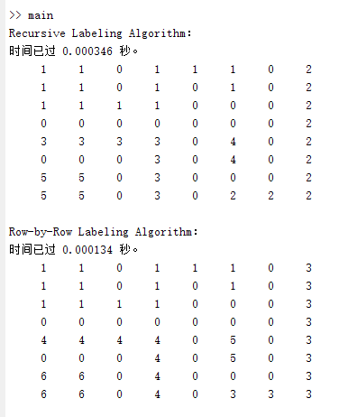

According the program, the Recursive Algorithm is slower than Row-by-Row labeling Algorithm.

Recursive Algorithm:

1. Slower
2. It consumes a lot of memory in computer

Row by Row Algorithm.

1. High-efficiency